Bahria University,

Karachi Campus



LAB EXPERIMENT NO.

**08**

LIST OF TASKS

|  |  |
| --- | --- |
| TASK NO | OBJECTIVE |
| 01 | Configure static route on the following network and show all necessary configuration steps for each router. |
|  |  |

Submitted On:

**06/12/2023**

**LAB 08 CONFIGURING ROUTERS**

**TASK 01**

**STEP 01(CONFIGURING ROUTER)**

**Router 1**



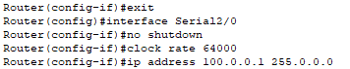

**Router 2**



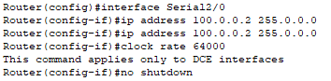

**STEP 02 (IP ADDRESS,SUBNET MASK & DEFAULT GATEWAY ARE SET FOR ALL THE PCS)**

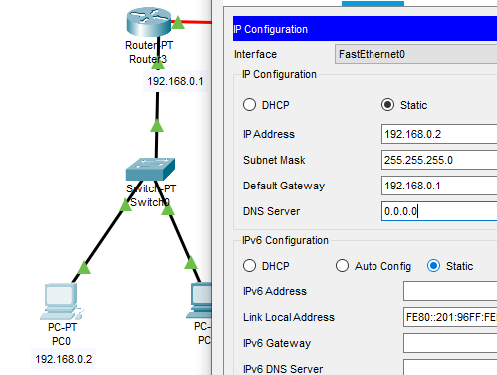

**STEP 03 (CONNECTIONS FROM PC TO ROUTER OR TO PC WITHIN THE SAME NETWORK ARE SUCCESSFUL BUT WITHIN DIFFERENT NEWTWORK ARE FAILED)**

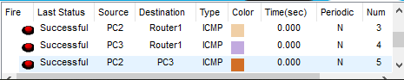

**STEP 04 (SPECIFYING THE NETWORK,SUBNET MASK & NEXT HOP)**

**FROM ROUTER 1** 

**FROM ROUTER 2 **

**STEP 05 (PINGING)**

**PC3 TO PC2**

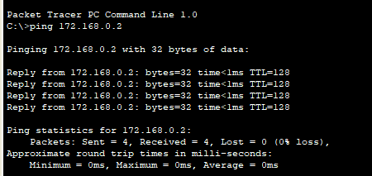

**PC2 TO PC1**

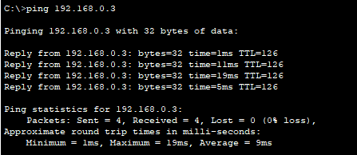

**PC0 TO PC1**

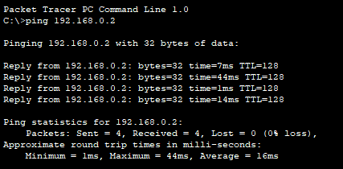

**PC0 TO PC2**

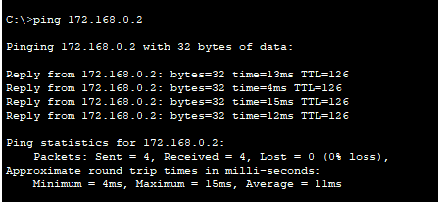

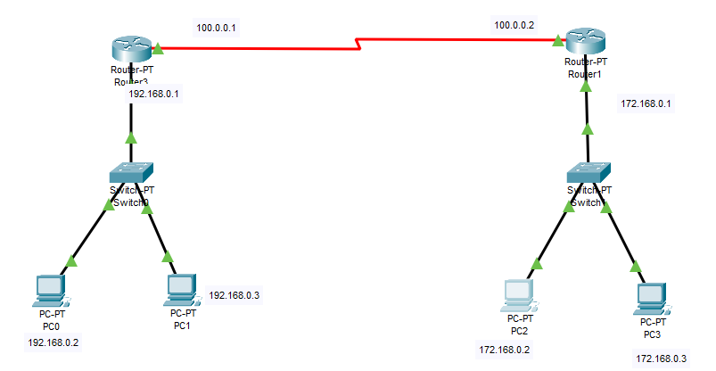

**TASK 02**

**STEP 01**

**ROUTER 3**

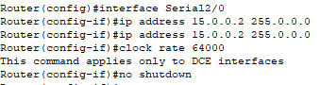

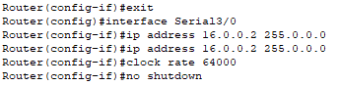

**ROUTER 1**

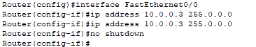

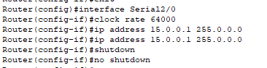

**ROUTER 2**

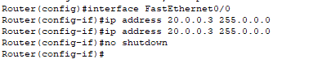



**STEP 02**

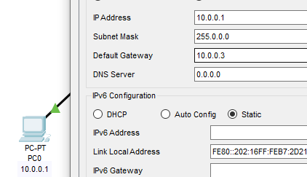 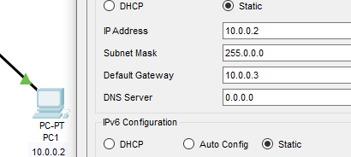

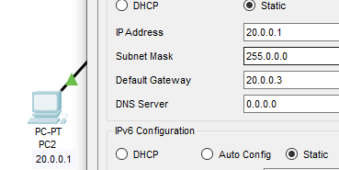 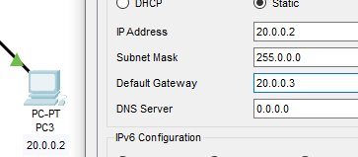

**STEP 03**

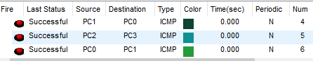

**STEP 04**

**ROUTER 01**



**ROUTER 02**



**ROUTER 03**



**STEP 05**

**PC0 TO PC2**

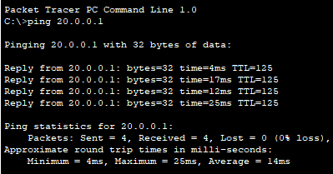

**PC3 TO PC1**

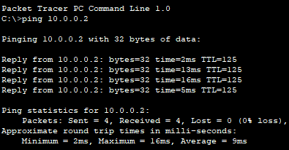

**PC2 TO PC1**

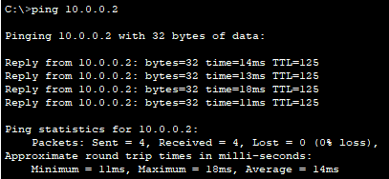

**PC1 TO PC3**

